Installation of Python with PyCharm on Windows.

PyCharm is an IDE which is used for development in python. It is one of the best IDE used by developers. PyCharm is developed by JetBrains and can be customized with different themes and plugins. It provides suggestions while coding and is very helpful for starters.

Let us see the procedure to download it in windows.

Step 1:

First You need to install Python. For downloading python visit <https://www.python.org/downloads/>

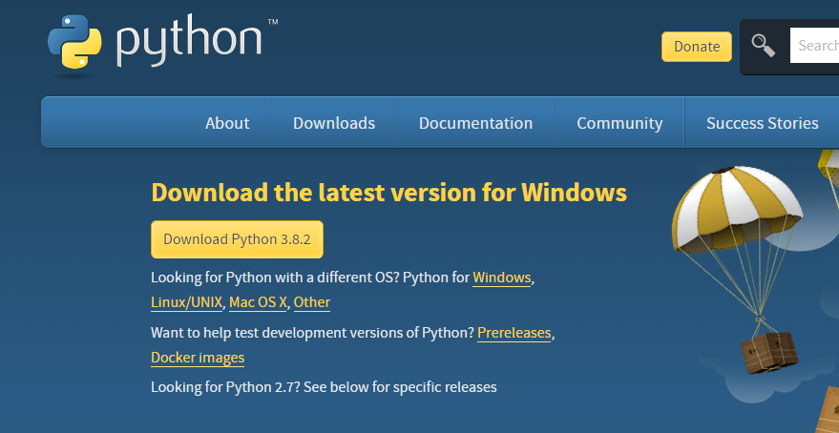

Step 2:

Click on the Install Now. And remember to check the following:

1) Install launcher for all users.

2) Add python to 3.8 to path.

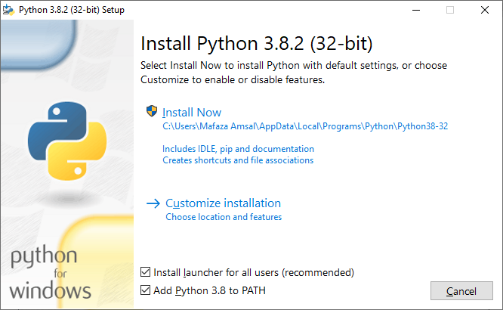

Step 3:

The installation will start automatically. Wait for completion.

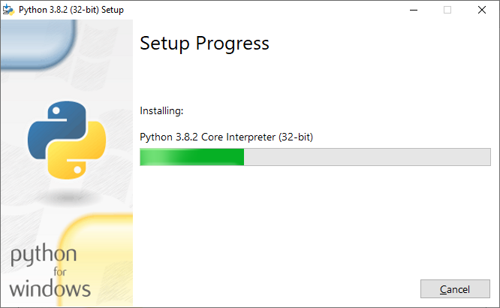

Step 4:

After completing the installation this window will come. Disable path length limit by clicking on the Disable. Then you are good to go.

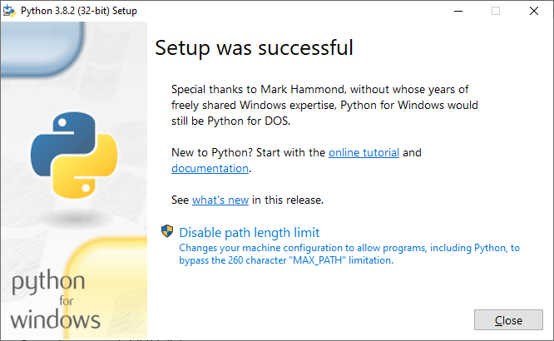

Congratulations you have successfully installed Python on you system.

Now let us install the PyCharm.

Step 1:

Open a browser and visit this link

<https://www.jetbrains.com/pycharm/download/#section=windows>

You will see the following page. PyCharm provide two versions

* Community
* Professional

Being a starter download the community version. It is open-source and absolutely Free.

Depending on your connection speed it will take two to five minutes.

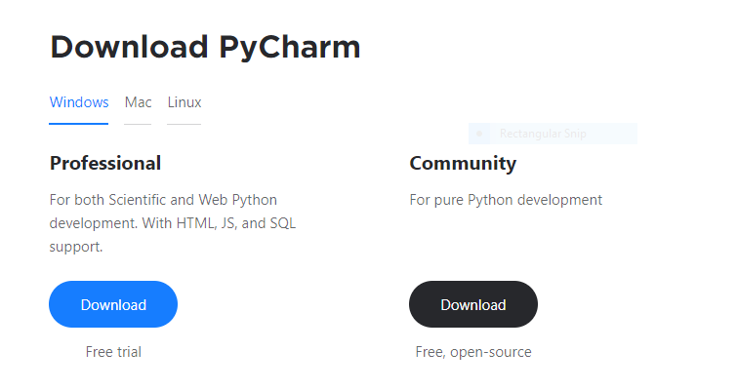

Step 2:

Open the exe file which will probably in the download folder of your windows. Run the exe you will see the following window. Click Next.

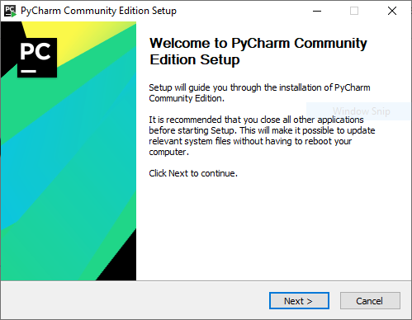

Step 3:

After Clicking next you will see the following window. It is asking for choosing the location for installing PyCharm. It is recommended to install it at the default path. Then click next.

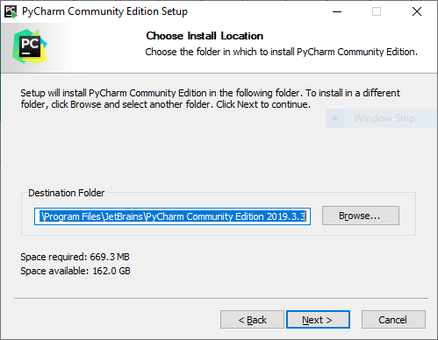

Step 4:

After clicking next you will be forwarded to the following window. Choose the Create folder on Desktop if you want to create a shortcut on your desktop. Leave the rest as they are and click next.

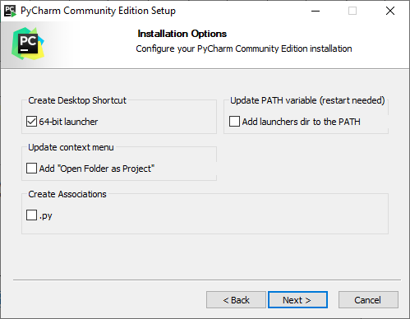

Step 5:

Leave the JetBrains selected and click install.

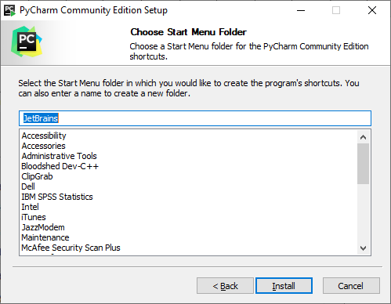

Step 6:

Here you go the installation will start and wait for it be finished.

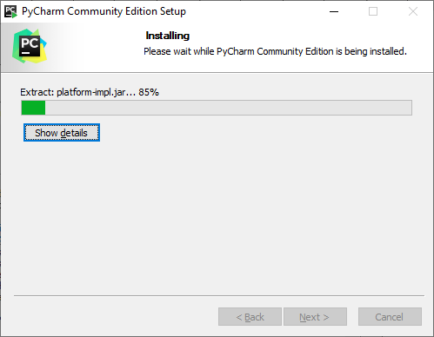

Step 7:

Click on the Run PyCharm and click finish.

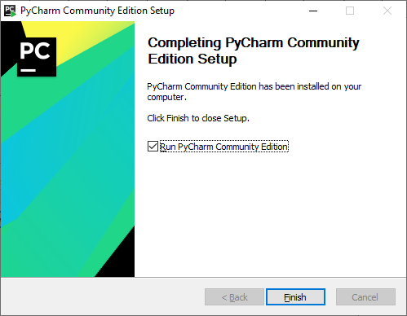

Step 8:

Accept the JetBrains privacy and policy and press continue.

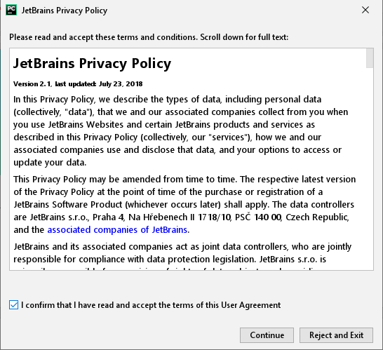

Step 9:

Do select “send usage statistics” as it will help the PyCharm to improve itself.

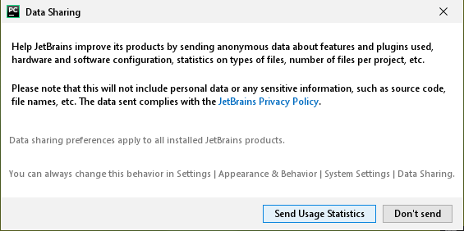

Step 10:

Now the fun part begins. Choose the theme light or black, whichever suits you.

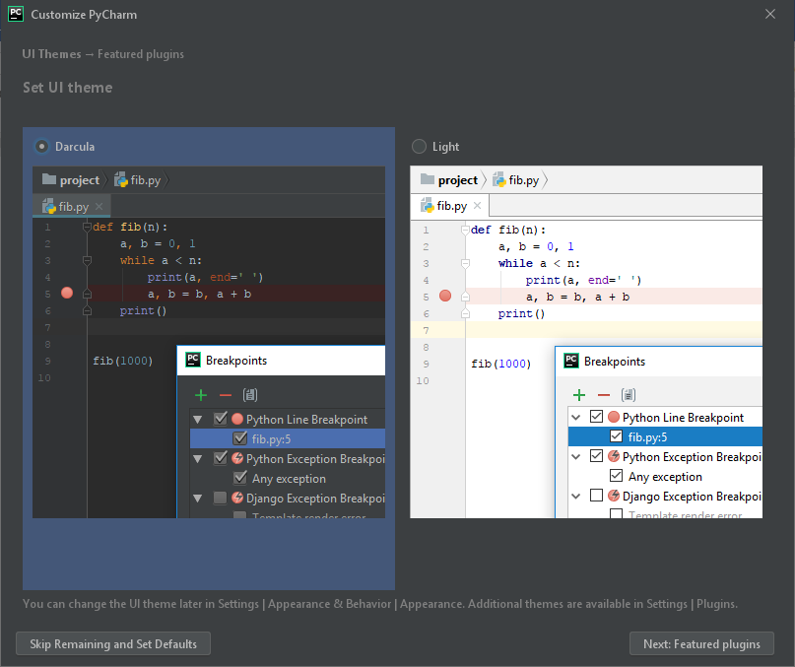

Step 11:

Here are some other features provided by the PyCham. They have nothing to do with Python.

And press Start using PyCharm.

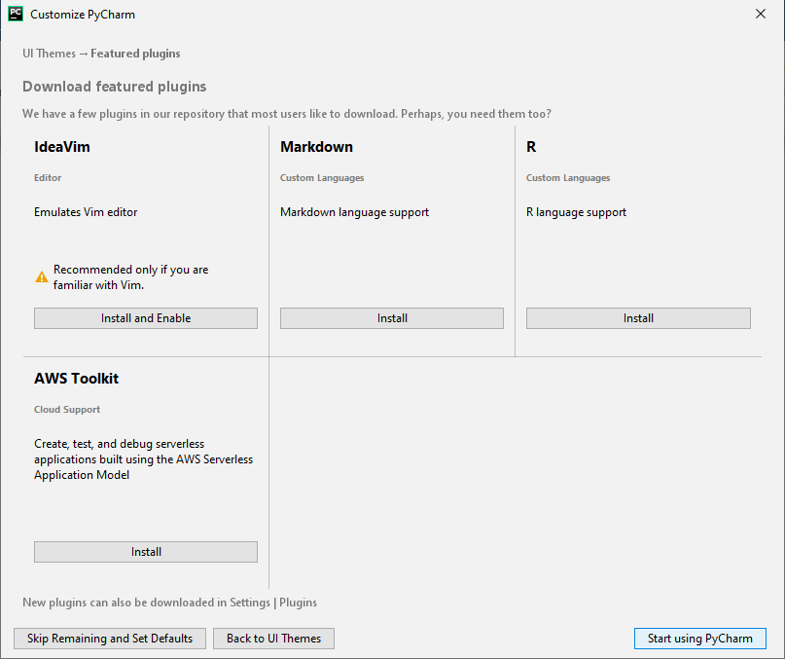

Step 12:

You have successfully installed the Pycharm

Now click on “Create New project”

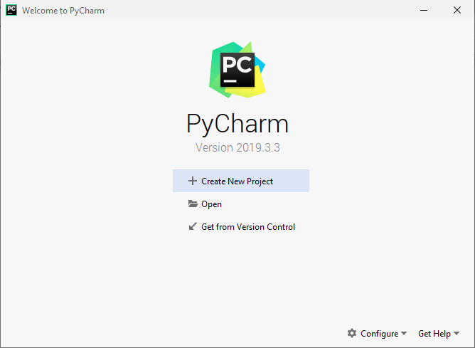

Step 13:

Rename you project name and select “create”. You are good to go.

